Search for a Training Program

The Search for a Program function allows users to search for and view training program information. The Search function consists of the following three windows:
- Search for a Program
- Search for a Program - Initial Results
- Search for a Program - Detailed Results
Search for a Training Program Window
The Program Search window allows for the entry of search criteria. Users can search for all training programs near a particular location and within a designated mile radius, or can search for a specific training program by entering a program name. In order to perform a geographic search, users must enter a zip code, city or state. Users can further narrow the search to a particular type of training program or search according to a program status and/or setting.

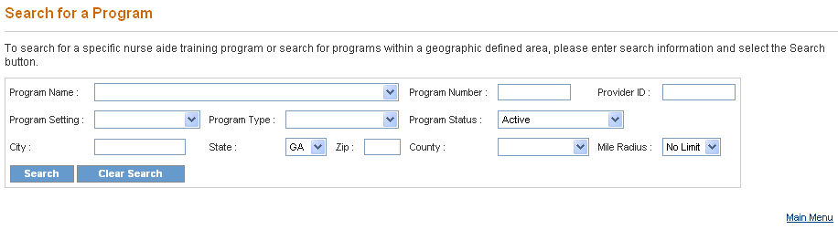
- On the Search screen, enter one or more training program search criteria. The more specific the search criteria, the faster the search. To search for a specific program, select the program name from the Program Name drop down list, and/or enter the program number in the Program Number field. To search by Provider ID, enter the number in the Provider ID field.
- To limit the search to a particular type of training program, select a type from the Program Setting drop down list (acute facility, high school, home health agency, nursing home, private school and vocational college).
- To search for a program by status, select a status type from the Program Status drop down list (active, closed, expired, involuntary withdrawal, voluntary withdrawal).
- In order to perform a geographic search for a training program, a zip code, city or state must be entered. Enter the five-digit zip code for the search location in the Zip Code field. If the zip code is not known, enter a city in the City field, and select a state from the State drop down list or utilize the default setting for state which is Georgia.
- Other geographic search criteria may be entered to limit the search. Select a county from the County drop down list.
- The default setting for the Miles Radius field is No Limit. To search for a training program within a different miles radius, select the preferred miles radius by clicking one of the Miles Radius radio buttons.
- Once all search criteria are entered, click the “Search” button at the bottom of the screen. The information entered is validated by the system. If an error message appears, make corrections and click the “Search” button again.
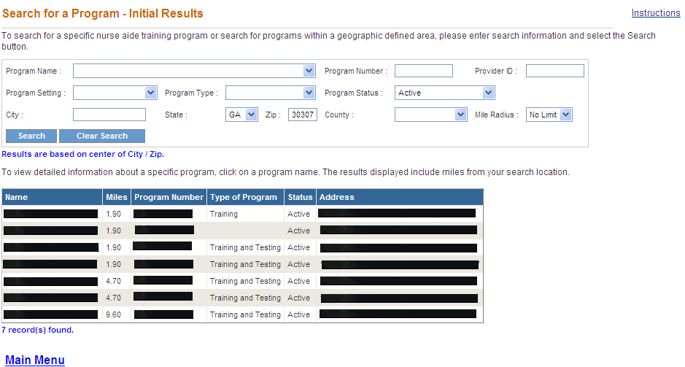
- If there are no matches to the search criteria, a “0 record(s) found” message is displayed. Search again by entering new search criteria and/or by expanding the geographic search area and then click the “Search” button at the bottom of the screen.
- If the search is successful, a Search for a Program – Initial Results screen presents that lists the search criteria entered and displays all the training programs matching any of the search criteria. For each result, this screen provides the name of the training program(s), distance in miles from the search location, program number, type of program, program status and address.
- The screen also displays the total number of results found. To view the next set of results, click on “Next.” To return to the previous set of results, click on “Previous.”
- To search for another program, click the “Clear Search” button at the top of the screen and enter new search criteria.
OR
- To view detailed information for a training program, click on the name of the program in the Name Column. The Add/Edit a Program screen is displayed. This screen provides the following detailed information for the selected program.
- Program Name
- Program Setting
- Program Type
- Program Status
- Approval and Withdrawal Date
- Information for Primary Contact
- Address, City, State, Zip Code and County
- Phone Number 1 and 2
- Fax Number
- E-Mail and Web Site Address
- Testing Site (yes or no)
- Course Book Name
- Information on Additional Classroom Training Sites
- Instructors associated with the Program
- Program Courses associated with the Program

