CMO PA WEB SUBMISSION

Behavioral Health

Behavioral Health Outpatient
Services
Certified Community Behavioral Health Clinic

Provider User Manual – Version 2.0

CMO PA Overview

The Georgia Web Portal serves as the centralized portal for the submission of Fee-for-Service (FFS) authorization requests, and authorization requests for certain services provided to Medicaid members enrolled in a Care Management Organization (CMO). The centralized PA submission process for CMO PAs is being phased in over time. This means that different CMO authorization request types will be added during each phase. The following table provides a summary of the request types that have been added thus far, and what is projected.
.

Table of Contents
General Submission Requirements 3
Behavioral Health PA Submission 5
Initiate a New Behavioral Health Outpatient Services Request 5
Enter Form Data 12
CMO PA Search 24
Updates to CMO PAs 30
Attach Documents to the PA 30
Submit a Change Request 35
Submit a Request for Reconsideration 37

General Submission Requirements

Member/Provider Validation
When a CMO PA request is initiated, the user is prompted to identify the specific CMO (Amerigroup, or Peach State) in which the member is enrolled. The member ID is validated against CMO member eligibility. In addition, the provider ID(s) is/are validated against CMO provider affiliation. If the member ID or provider ID is not associated with the CMO selected, a warning message informs the user that the member and/or provider does not appear to be associated with the selected CMO. Member enrollment validation is a ‘hard edit’ which prevents the provider from entering the request. Provider validation is a ‘soft edit’, and the provider may bypass the warning message and enter the request.

Tracking Authorization IDs
CMO PAs submitted via the portal are assigned a 12 digit Alliant tracking ID that starts with “7”. The requests remain in ‘Pending’ status until a decision is rendered by the CMOs. The CMOs are responsible for processing the PAs and submitting back to Alliant for the review determinations and CMO authorization numbers. The CMO assigned authorization number is loaded to the PA on the Medical Review Portal and displays in the ‘CMO PA Request ID’ field. The CMO authorization number is the number used for claims submission/adjudication.

Medical Review Portal Functionality

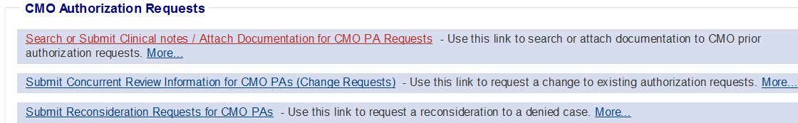
The portal Medical Review Portal has been customized with functions applicable to CMO PAs.
Figure 1
The following table provides a description of the functions available:

Function | Description
CMO PA Search | Find PAs, view decisions, and view PA data for existing Behavioral Health PAs.
Attach File | Attach additional clinical data to the CMO PA

Submit Change Requests | Submit a change request for any Pending CMO PAs.
Submit Reconsideration Requests | Submit a reconsideration of a denied CMO PA.
Table 1

Behavioral Health PA Submission

There are two forms related to Behavioral Health Services available on the Centralized PA portal
- Behavioral Health Outpatient Services form-This is submitted by providers with a 440 Category of Service
- Certified Community Behavioral Health Clinic (CCBHC) form-This is submitted by providers with a 443 Category of Service
Both forms are via the centralized portal. The CCBHC form follows the same process that has been used historically for submitting Behavioral Health Outpatient Services.

Behavioral Health and Outpatient Services form
The Behavioral Health and Outpatient Services form is completed for all members, enrolled in a Medicaid Care Management Organization, who request services for Behavioral Health. This form should only be used for Behavioral Health and not used for Psychiatric Testing services. Additional documentation, such as treatment plan, reauthorization clinical information, psychological testing information, integrated services, and case manager referral, may be attached to the Behavioral Health and Outpatient Services at any time based on the PA status.

Providers can submit PA requests for members enrolled in a Medicaid Care Management Organization via the GA Web Portal utilizing an entry/submission process similar to submitting PAs for FFS Medicaid members.

Initiate a New Behavioral Health Outpatient Services Request
Follow these instructions to initiate a new CMO PA request.

- Go to the GA Web Portal at www.mmis.georgia.gov.

- Login with assigned user ID and password.

- On the portal secure home page, click the Prior Authorization tab.

- Then, click Submit/View; or click Medical Review Portal and, on the workspace page, select Enter a New Authorization Request.

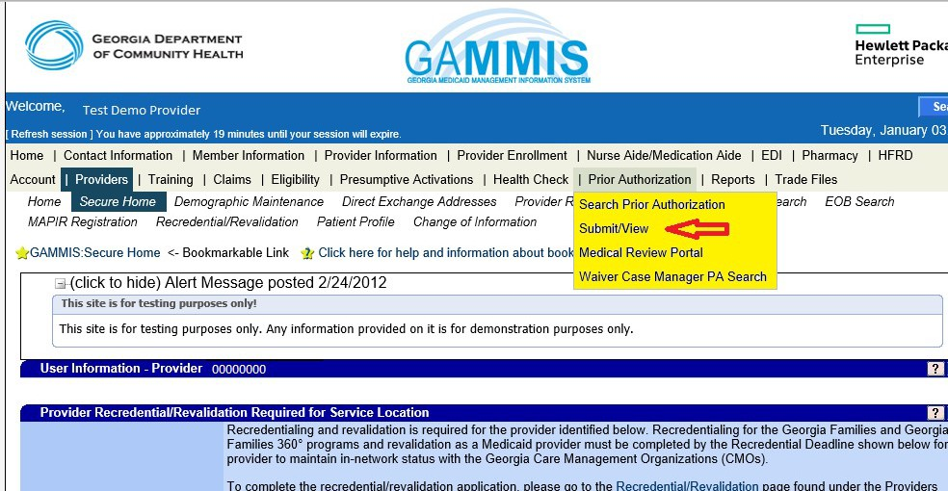
Figure 2

- A list displays with request types applicable to the requesting provider’s category of service. For example, the following list displays when a physician provider is logged into the portal. The following links display for the provider logged in as Behavioral Health provider and CCBHC provider, respectively.

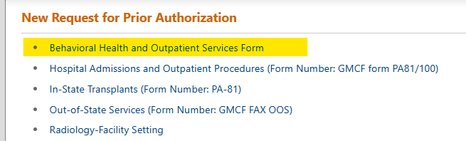
Figure 3

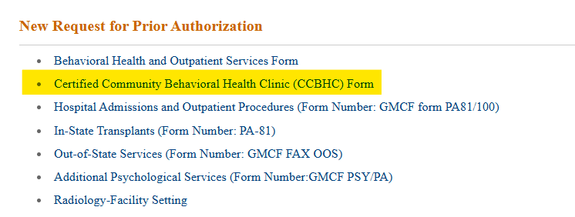
Figure 4

- In both cases, select the appropriate form.
- On the next page, select the CMO. Note that the header on the page changes based upon the form selected (Behavioral Health and Outpatient Services Form vs Certified Community Behavioral Health Clinic (CCBHC) Form). There are no other differences, so the remainder of this document will not show both screen shots.
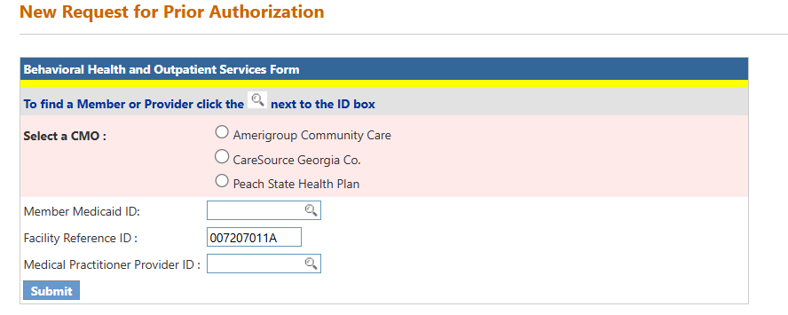Figure 5
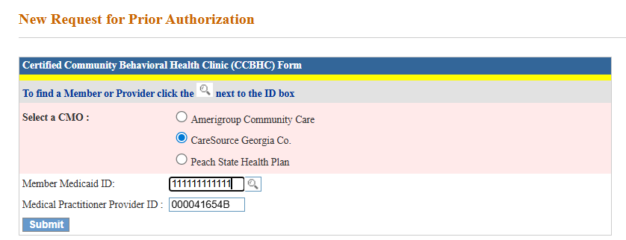
Figure 6
- Enter the Member ID. The member id can be searched using the Search Icon and entering the data on the following page.

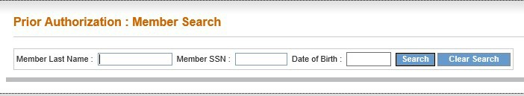
Figure 7
- If the member is associated with the selected CMO, the request form opens.

- If the member ID is not associated with the selected CMO based on member file data, a message displays indicating that ‘Member is not enrolled in selected CMO’. A similar message displays if a provider is not affiliated with the selected CMO.

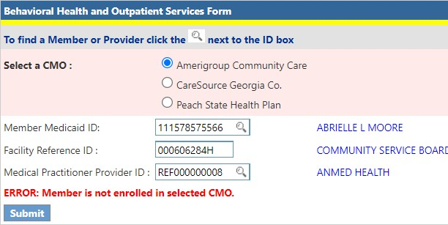
Figure 8

- The requesting provider ID is populated by the system based on the portal login. Enter the Reference ID for the other provider in the box provided. The reference number always starts with REF.
- The Reference Provider ID can also be searched using the Search Icon and entering the search data on the following page.

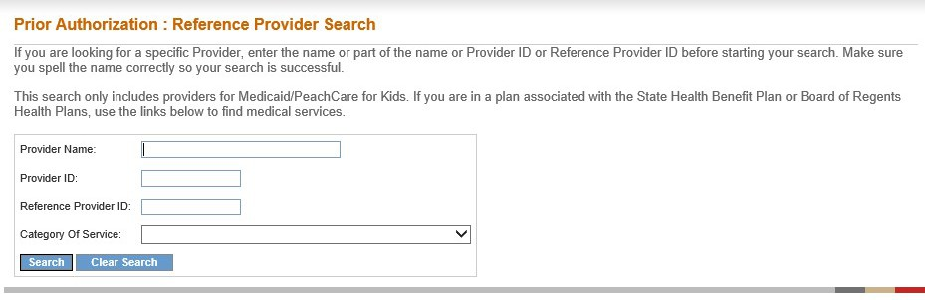
Figure 9
- A Reference Provider ID is optional to initiate a Behavioral Health Prior Authorization.

- If the Reference Provider ID is not enrolled with the CMO then the warning message “Provider is not associated with the selected CMO” is displayed. However this does not prevent the PA submission. Click on “Continue..” in order to proceed with the PA submission.

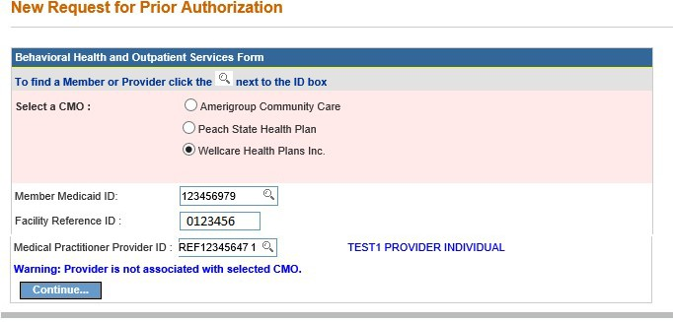

Figure 10

- Member Validation Message: Be sure the correct CMO was selected, and the member ID was entered correctly. If not entered correctly, fix the data and re-submit. If the data was entered correctly, but the message persists, check with the specific Care Management Organization to verify CMO enrollment.

- Provider Validation Message: A warning message also displays if the provider is not affiliated with the selected CMO. However, this message may be bypassed by clicking Continue, and the request can be entered. After entering the request, check with the CMO to confirm affiliation status.

- Click Submit to open the form. Please note that the remainder of the manual shows the Behavioral Health Outpatient Services form. The data entry requirements for it and CCBHC are the same, so only one end to end submission is being shown.

Enter Form Data

Member/Provider Information
When the notification form opens, the member and provider information is system auto populated at the top of the page based on the member ID and provider IDs entered. These sections cannot be edited and are read-only fields.

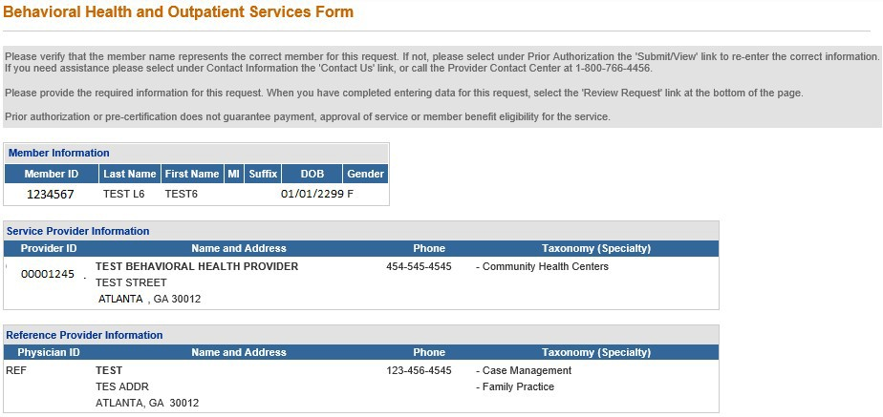

Contact Information
Figure 11

The system also populates the requesting provider’s contact information in the Contact Information section. The ‘Contact Name’, ‘Contact Phone’, and ‘Contact Fax’ are required. If any of this information is missing, enter the information in the boxes provided. All contact information may be edited if incorrect.

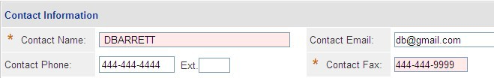
Figure 12

Primary Care Physician (PCP)
This section captures the PCP Information for the member. This section is an optional section. Therefore, the information in this section does not have to be entered in order for PA to be submitted.
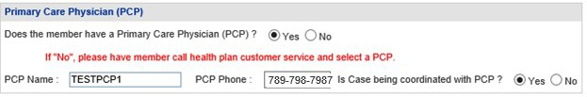
Figure 13

Request Information
This section captures the Type of Recommendation, the Initial Admit Date and the Place of Service.

- The “Type of Recommendation” selection can only be either “Initial” or “Reassessment” and not both.

- The “Initial Admit Date” can be either entered or selected from the drop-down calendar.

- The “Place of Service” is a drop down and only one value can be selected. There are four options (a) 03 – School, (b) 11 – Office, (c) 12 – Home, and (d) 53 – Community Mental Health Center. All the information in this section has to be entered in order to submit the PA.

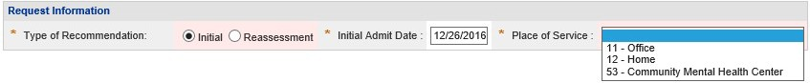
Figure 14

Diagnosis
The Diagnosis table captures the diagnosis code, code description, diagnosis date, primary diagnosis indicator, admission diagnosis indicator, and diagnosis type (ICD9 or ICD10). If the date of service is 10/1/2015 or greater, an ICD-10 diagnosis code should be entered. Only one primary diagnosis may be entered.

- The primary diagnosis must be entered on the first diagnosis line. Enter the diagnosis code in the ‘Diag Code’ box. If the code includes a decimal point, enter the code with the decimal point.

- It is also possible to search for a code by the diagnosis description. Click the spy glass symbol in the code box; enter the description; select ICD9 or ICD10; and click Search. Select the code and the system populates the diagnosis code in the code box.

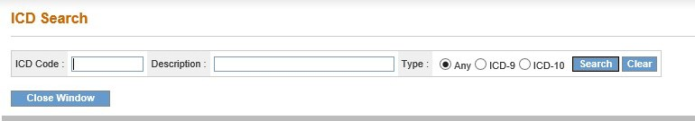
Figure 15
- Enter the date that the primary diagnosis was established in the ‘Date’ box.

- The system pre-populates the ‘Primary’ diagnosis checkbox and the ‘Secondary diagnosis checkbox on the first diagnosis line. Check only one box either Primary or Secondary. At least one Primary Diagnosis code needs to be entered. If you add both the primary and secondary diagnosis check, an error message will display when an attempt is made to add the Diagnosis code as “Either Primary or Secondary Diagnosis has to be selected, not both at one time”. If the “Primary” is checked first, then the next lines can be checked on “Secondary”. The ‘Secondary’ checkbox may be unchecked also.

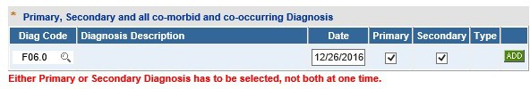
Figure 16

- Click Add to add the primary diagnosis code information to the request.
- Follow the same process to add other diagnosis codes, as applicable. Remember to click
Add after each line of diagnosis information is entered.
- If the Diagnosis code needs to be edited or deleted before the PA submission, then this can be achieved by clicking on the “Edit” or “Delete” button.

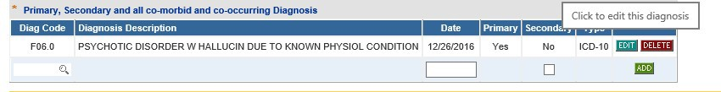
Figure 17

- Once the Diagnosis line is edited, click on “Save” to save the changes or “Cancel” to revert the changes.

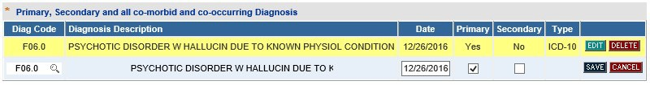
Figure 18

- If the diagnosis code is entered which is not 5010 compliant (meaning that the code is unspecified or not specific enough), this warning message displays: Invalid or unspecified code and/or has a more specific ICD code value. Please check your input. When this message displays, the diagnosis code must be changed in order to proceed with the request.
- There is no restriction for the number of Diagnosis lines that can be entered.

Procedures
The Procedures Table captures CPT Code(s), dates of service, requested units, and number of visits per week. If the requesting provider is a participating provider in the selected CMO’s network, a direct link to the CMO’s PA lookup tool is provided above the procedures section as shown in the next figure. The lookup tool may be used to determine if a procedure requires a PA.

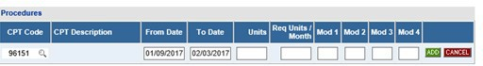
Figure 19

If the provider associated with the request is not a participating provider, the Lookup Tool is not available and this disclaimer displays: “It does not appear that <<provider name>> associated with this request is a CMO participating provider. Consequently, all requested procedures/services require prior authorization.”

Enter the procedure code for the service requested in the ‘CPT Code’ box; or search for the procedure code and the system inserts the procedure code.
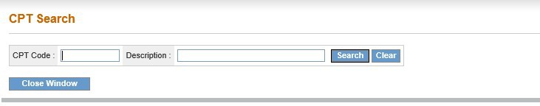
Figure 20

- In the ‘From Date’ box, enter the start date of service, and, in the ‘To Date’ box, enter the end date of service. Each procedure line may be entered for up to 180 days. If the number of days requested is more than the allowed span, a message will be displayed and the Procedure line shall not get added. The date span validation is for submission purpose only.
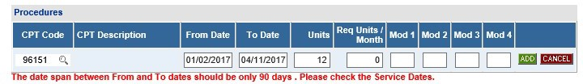
Figure 21
- In the ‘Units’ box, enter the number of visits requested during the procedure date span.

- In the ‘Req Units/ Month’, the number of units requested per month shall be entered.

- If there are modifiers that are requested, they could be added under Mod 1, Mod 2, Mod 3, and Mod 4. The modifier values are optional and not all modifiers need to be added.

- For any given Prior Authorization, two lines can have the same Procedure, Date, and Modifier combinations.

- However, if a Prior Authorization was already submitted for a member with a particular Procedure, Date, and Modifier combination, then a new PA with the same Procedure, Date, and Modifier combination will be allowed.

- Click on the “Add” button to add the Procedure line.

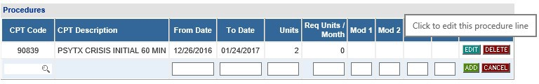
- If the Procedure line needs to be changed, it can be edited or deleted before the PA is submitted. No changes can be made after the PA submission to the Procedure and Diagnosis lines.
Figure 22

- Once the Procedure line has been edited, click on “Save” to accept the changes and “Cancel” to revert the changes.
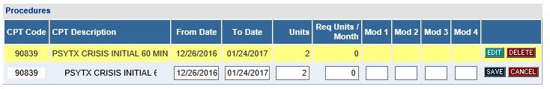
Figure 23

Comments
- The Comments section is a required field to add any additional comments the Provider may have regarding the PA.
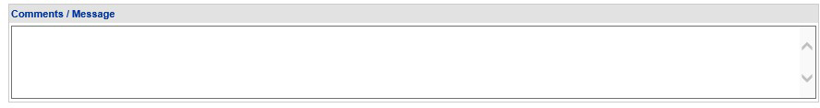
Figure 24

- The comments section shall not allow any special characters and shall display “Invalid Characters” if they are entered.

- There is a text limit for the comments; no more than 4000 characters are allowed.

Current Clinical Information
- The current clinical Information gathers various information under the following headings – Anxiety Disorders, Depression, Mania, Substance Abuse, Psychotic Disorders, and Personality Disorders.
- Each of the fields has a drop down with the values N/A, Mild, Moderate, Severe, Acute, and Chronic.
- At least one appropriate value from the drop down needs to be selected. If no value is selected, then the default value is set to N/A.
- All the fields are required and therefore unless all the data is entered, the PA submission will not be able to be completed.
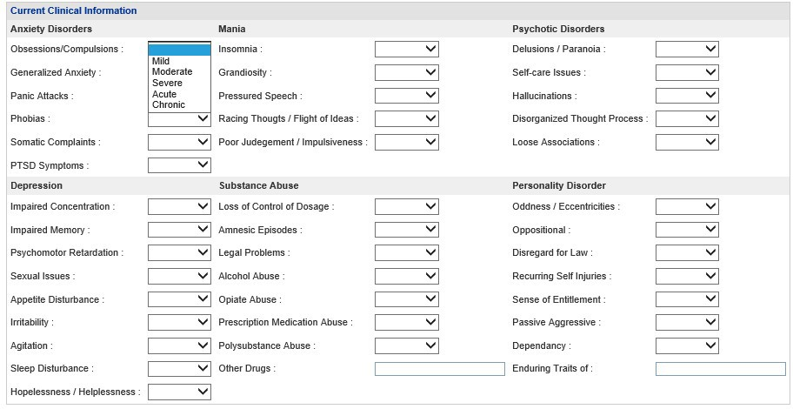
Figure 25

Level of Care
The Level of Care has various information that needs to be filled in. All the fields are required. The fields accept up to 4000 characters. Like other descriptive text fields, these fields also do not allow special characters. Therefore, it is suggested to avoid copy and paste directly from other sources of data. If the information is lengthy, then it is suggested to attach the file instead of a copy and paste. The following are the categories of level of care information collected:

Risk of Harm

Figure 26

Functional Status
Figure 27

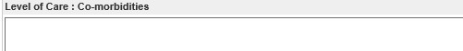
Co-morbidities
Figure 28

Environmental Stressors
Figure 29

Support in the Environment
Figure 30

Response to Current Treatment Plan
Figure 31

Acceptance and Engagement
Figure 32

Transportation Available
Figure 33
Presenting Problems
Figure 34

Current Need for Treatment
Figure 35

Detail Member Behavior within Past 30 days
Figure 36

Other Clinical Information
Figure 37

Current Medications Figure 38

Medications
- The medication section is for entering any prescription medicine the member has used, is currently using, or is planned for future ues. This section is optional.

- The Medication Name, Date Prescribed, and whether the member is complaint with Medication is calculated.

- The Date Prescribed is an optional information to be entered.

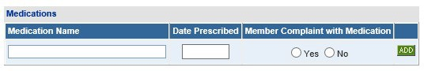
Figure 39

History
- This section is an optional section.

- The History section gathers the Hospitalization information.

- The section has a drop-down list that can be selected for the appropriate value.

- The Admission Date is to be entered and Discharge Date information is optional for each line.

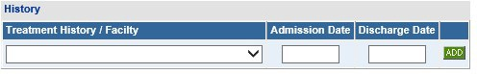
Figure 40
- The drop-down list has the following information that can be selected.

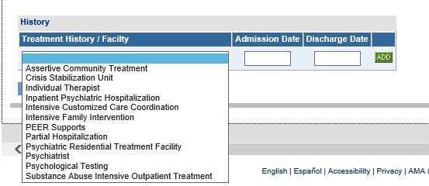 Figure 41

When all data has been entered on the notification form, click Review Request at the bottom of the page to display the Attestation Statement. If a message displays that ‘information is missing or incorrect’, scroll up the page to find out what is missing or incorrect. ‘Required’ displays next to a data box when information is missing. Enter or correct the data, and then click Review Request again.
  - Review the Attestation Statement and, if in agreement, click I Agree. You must click I Agree to submit the notification form.

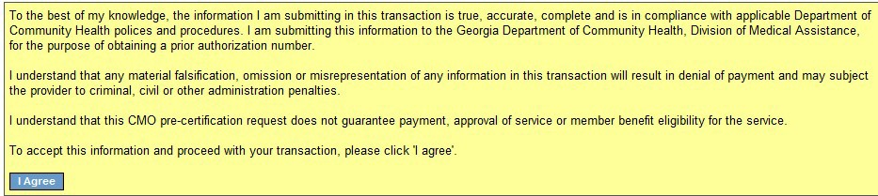
Figure 42
  - Review the information entered on the form. To change information entered, click Edit Request. Once a form is submitted, it is not possible to return to the form and make changes.
  - Click Submit Request. When the form is successfully submitted, the system displays a 12 digit Alliant tracking number that starts with a ‘7’. This number can be used to search for the PA via the Medical Review Portal.
  - To enter a new request or notification form under the same Portal ID/provider, click Enter a New PA Request. The request type menu page re-displays.

CMO PA Search

Providers may search for CMO PAs and view PA decision status utilizing the CMO search function available on the Medical Review Portal.

Search Instructions

- Go to the GA Web Portal at www.mmis.georgia.gov.

- Login with assigned user ID and password.

- On the portal secure home page, click the Prior Authorization tab.

- Click Medical Review Portal.

- Under CMO Authorization Requests, select Search or Submit Clinical notes / Attach Documentation for CMO PA Requests to open the search page.
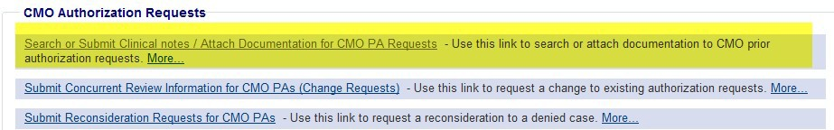

Figure 43

- The search page opens with the provider ID auto-populated, and the ‘Select CMO’ indicator defaulted to ALL.
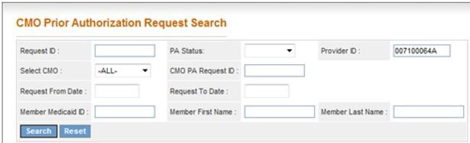
Figure 44

The provider ID is associated with the portal login credentials or is populated based on the provider ID that the user ‘switches to’ after login. The provider ID cannot be changed on the Search page. The ‘Select CMO’ indicator may be changed to a specific CMO.

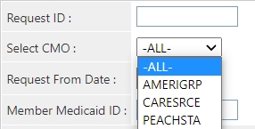
Figure 45
- The best way to search for a specific case is by the Alliant Tracking number also known as the ‘Request ID’. The Alliant Tracking number is a 12 digit number that starts with a ‘7’ and is assigned to each CMO request when the request is submitted via the web portal. Follow these instructions to find a specific PA using the Alliant tracking number:

  - Enter the Alliant Tracking number in the ‘Request ID’ box
  - Leave the ‘Select CMO’ indicator as ‘All’ CMOs.

  - The provider ID is populated by the system in the ‘Provider ID’ box. This provider ID must match the provider ID associated with the PA or the search will not work.
  - Do not enter any other data.
  - Click Search. The CMO PA displays below the search fields.

- When the Alliant tracking number is not known, it is possible to search using the following search parameters:
Parameter | Description
CMO PA ID | The CMO authorization ID assigned by the CMO.
PA Status | The overall PA status. For PAs with procedures, the PA status is derived from  the line level decisions but is not always the same.
‘Select’ CMO | Search for CMO PAs for ALL CMOs; or narrow the search to a specific CMO  (Amerigroup, or Peach State)
Request From and To Dates | Request Date is the date that the PA was entered into the PA system.  Search by these date parameters to find PAs entered within a specified time period.
Member Medicaid ID | The Member’s Medicaid ID number. This is the member’s Medicaid ID and  not the CMO member ID.
Member Name | The Medicaid recipient’s first name and last name.
Table 2

9. To find CMO PAs requested during a specific period of time: Select ‘All’ CMOs or select the specific CMO from the ‘Select CMO’ drop list. Next, enter the Request ‘From’ Date and the Request ‘To’ Date. These dates relate to the dates that the PA was submitted
via the portal. To further limit the search, select a ‘PA Status’: Pending, Approved or Denied. Click Search.
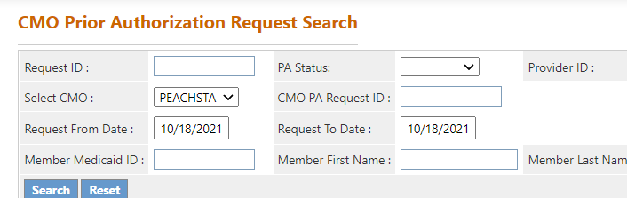
Figure 46

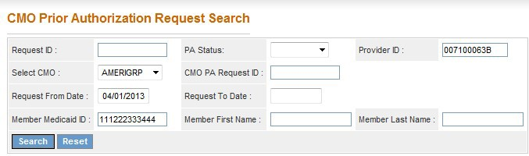
Figure 47

10. To find a PA for a specific member and CMO: Enter the member’s Medicaid ID (or
first and last name); and select the CMO name from ‘Select CMO’ drop list. To further limit the search so it does not return numerous PAs, enter a Request ‘From’ Date. Click Search.

Search Results
When a search is successful, the results display below the search fields. If searching by the Alliant Tracking number (Request ID) or CMO PA Request ID, only one result will display.
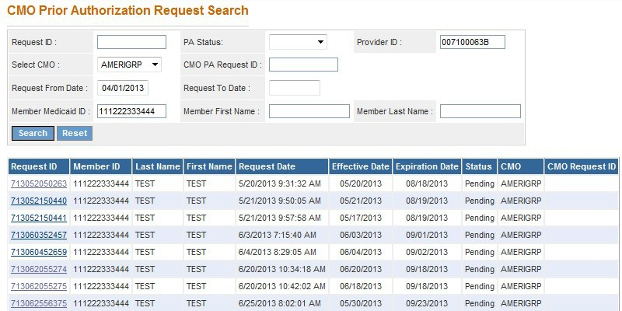
Figure 48

The search results also display the status of the PA (Pending, Approved, Denied); and the CMO Request ID (authorization number) if this information has been received from the CMOs.
Cases that are ‘Pending’ (not processed by the CMO) will not have a CMO Request ID.
- To view details for one of the cases listed in the search results, click a Request ID
(noted in blue font).
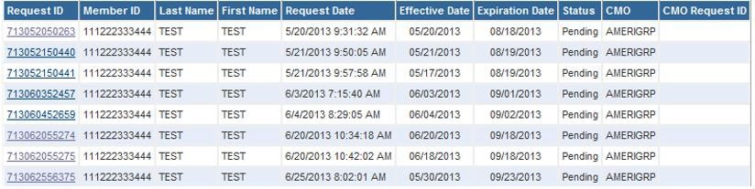

Figure 49

- When a request ID is selected, the PA Review Request page opens.

Review the Request
The Review Request page provides an overview of the request information and provides the decision information. The information displayed always includes: Member ID, Provider ID, PA decision status, and diagnosis code(s). Other information displays depending on PA type and may include: PA error descriptions, clinical data, procedure code(s) and procedure decision(s).

In general, when the CMO renders a decision, the CMO authorization number or denied number displays in the CMO PA Request ID under Request Information as shown highlighted below.
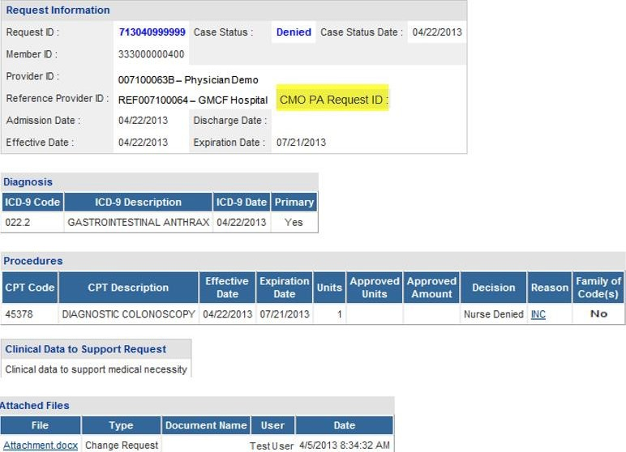
Figure 50

View Attachments
Documents attached to the PA display in the Attached Files table. To view an attachment, click the file name.
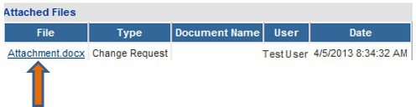
Figure 51

View Request Information Details
- To view request information details, click the Request ID in the Request Information
section.

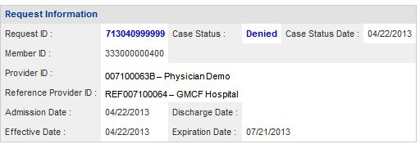
Figure 52

- When the ‘Request ID’ is selected, a page opens that displays all the information entered on the request when first submitted.
- Click Back to return to the Review Request page.

View Denial Reason/Rationale for PAs with Procedure Codes
To view denial reason/rationale for PAs with procedure codes, hold the mouse pointer over the denial reason code at the end of a procedure line to display the specific denial code description and denial rationale for that procedure line.

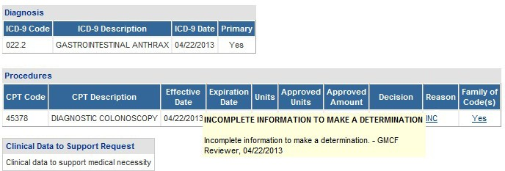

Figure 54
Hold mouse pointer over
the ‘Reason’ to display the reason description

Updates to CMO PAs

Providers may update CMO PAs via the web portal, except for CMO PAs initiated by the CMOs. One of the following rules must be met to update a PA:

- Attach documentation directly to the PA: Restricted to pending PAs,

Submit a Change Request and attach documents to the Change Request: Restricted to pending Pas

- Submit a Reconsideration Request: Restricted to denied PAs and according to each CMO timeline for reconsiderations. Amerigroup = 2 business days from denial date; For Peach state, the Reconsideration Request needs to be submitted to the CMO and not on the Georgia Portal.

Attach Documents to the PA
Providers may attach documents to pending CMO PAs. The following file types are acceptable for attachments: TXT, DOC, DOCX, PDF, TIF, TIFF, JPG, JPEG, JPE and XLS. The preferred attachment method is to attach one PDF file with all the necessary information. The file size for an individual attachment MUST be less than 20 MB in size. Multiple documents may be attached to one PA request, although each file must be attached individually, and each file must have a different name. Avoid using the following symbols when naming files: \, /, #, <, >, ‘, “.
Attachments can be done immediately after the PA submission.
Once the PA is submitted, scroll up and check the area for Attachment.
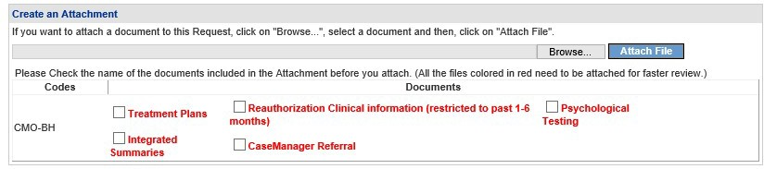
Figure 55

Click on “Browse”, select the files to be attached, and click on “Attach File”. Detailed instructions for this is presented below points 9 and 10.

Follow this process to attach a file if attaching at a later point:

- Open the Medical Review Portal.
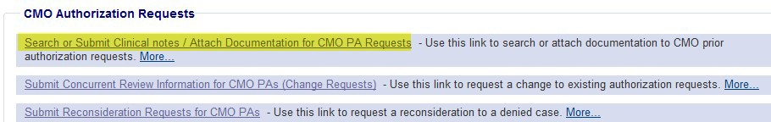
Figure 56
- In the CMO Authorization Requests section of the workspace, click on Search or Submit Clinical Notes/Attach Documentation to open PA request search.

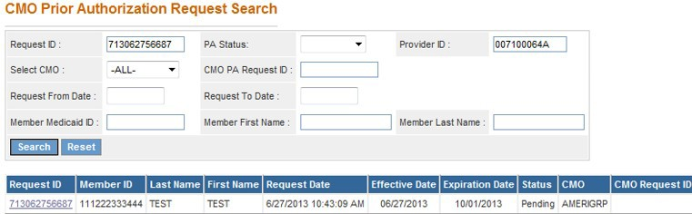
- Find the PA to which an attachment is to be made. Enter the ‘Alliant Tracking Number’ and click Search.
Figure 57
- Click on the Request ID to open the Review Request page.

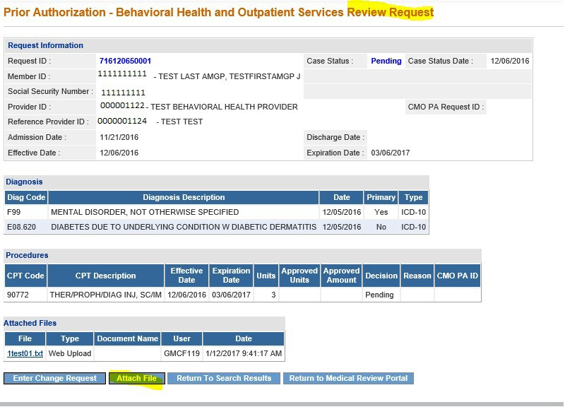

Figure 58

- Click the Attach File button.

- Go to the Create an Attachment section of the next page. The attachment panel will be available if the PA meets the criteria for attachments.

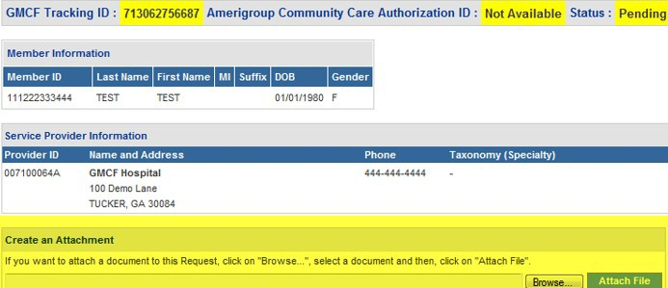
Figure 59

- In the attachment panel, click Browse.

- For BH PAs, there are ‘document type’ checkboxes. Click the appropriate checkbox or boxes, related to the documents to be attached, before selecting Browse.
Figure 60

The options available for the document type are “Treatment Plans”, “Reauthorization Clinical Information (restricted to pat 1- 6 months), “Psychological Testing”, “Integrated Summaries”, and “Case Manager Referral”.

- Browse opens the file directory. Find the file to be attached.
- Then, select the file by double clicking the file; or highlight the file and click Open.

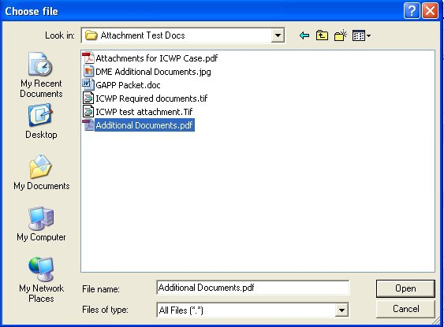
Figure 61
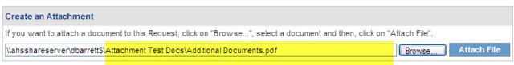
Figure 62

- Once the file is selected, the file displays in the attachment panel.

- Click Attach File. If the file is uploaded, the ‘File uploaded successfully’ message displays, and a link to the attachment displays in the Attached Files table.
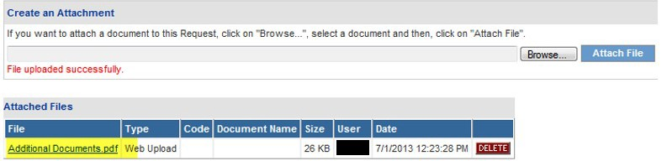
Figure 63

- If necessary, follow the same process to attach another file.

- To return to the main Review Request page, click the Back link at the bottom of the page.

Submit a Change Request
Change requests may be submitted if the PA is still pending. Documents can be attached to the change request.

To submit a change request, follow this process:
- Open the Medical Review Portal.

- Go to the CMO Authorization Requests section of the workspace.

Click Submit Concurrent Review Information for CMO PAs (Change Requests).

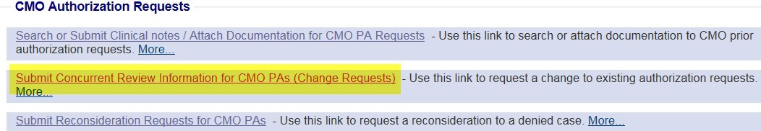
Figure 64
- Search for the PA that needs to be updated by entering the ‘Alliant Tracking Number’ and clicking Search.
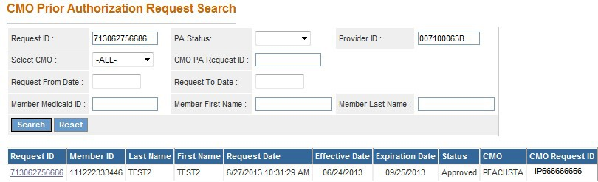
Figure 65

- Click on the Request ID to open the Review Request page.

- If the PA meets the criteria for a change request, the Enter Change Request button is available.

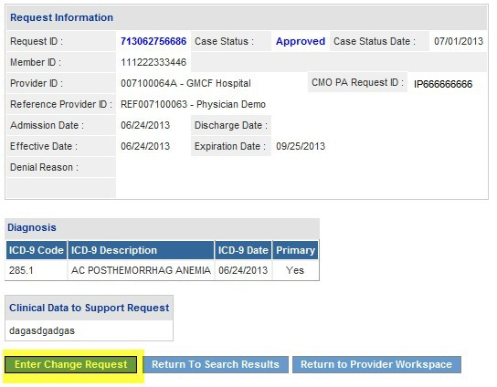
Figure 66

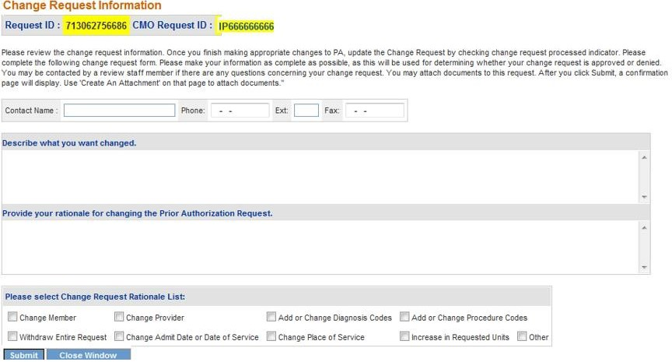
- Click Enter Change Request to open the change request form.

- Enter the contact person’s name, phone and fax number.

- In the first textbox, describe the reason that the change request is being submitted (to submit concurrent review information, or additional clinical).
- In the second textbox, provide justification for the requested change; or indicate ‘see attached’ when attaching documents to the change request.
- The checkboxes at the bottom of the page are optional.
- Click Submit to submit the request.

- If the submission is successful, a page displays confirming that the change request has been entered successfully.
- Additional supporting documentation files may be attached to the change request at this point. Follow the same attach file process as previously described.

Submit a Request for Reconsideration
A request for reconsideration may be submitted via the portal if the PA is denied and less than a certain number of business days (as prescribed by each CMO) has elapsed since the denial. The process used to submit a reconsideration is the same as submitting a change request. Documents can be attached to the reconsideration request.
To submit a reconsideration request, follow this process:
- Open the Medical Review Portal.

- In the CMO Authorization Requests section of the workspace, click on Submit Reconsideration Requests for CMO PAs.
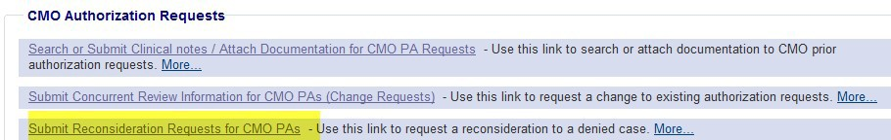

Figure 68

- Search for the denied PA. Enter the ‘Alliant Tracking Number’ and click Search.

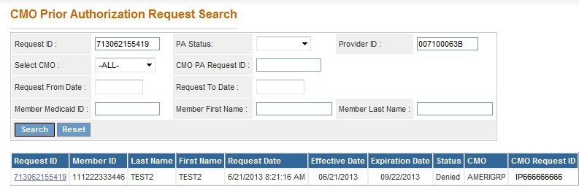
Figure 69

- Click on the Request ID to open the Review Request page.

- If the PA meets the criteria for a reconsideration request, the Enter Reconsideration Request button is available.

- Click Enter Reconsideration Request to open the form.
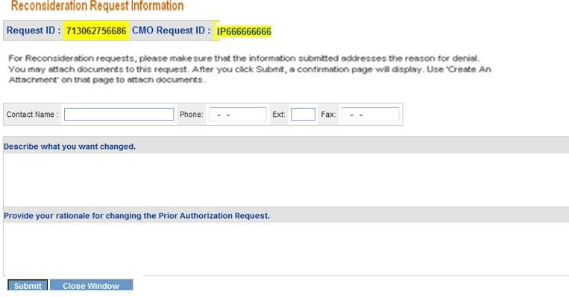
Figure 70

- Enter the contact person’s name, phone and fax number.

- In the first textbox, explain that a reconsideration request for denied PA ID is being submitted.
- In the second textbox, provide justification for the request for reconsideration; or enter ‘See Attached’ when attaching documents to the Reconsideration.

- Click Submit to submit the request.

- If the submission is successful, a page displays confirming that the reconsideration has been entered successfully.
- Additional supporting documentation may be attached to the reconsideration at this point. Follow the same attach file process as previously described.

