Search for a Nurse Aide

The Search for a Nurse Aide function allows users to search for certified nurse aide (CNA) information and verify the certification status of a nurse aide. The user enters at least one search criteria and, by entering additional search criteria, can narrow the search to a specific nurse aide. The Search for a Nurse Aide function consists of two screens: Search for a Nurse Aide and Search for a Nurse Aide - Initial Results.

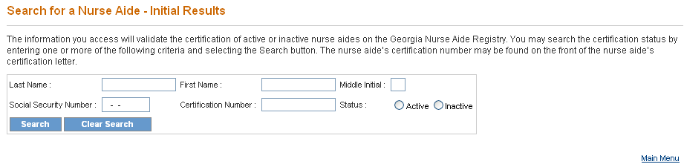
- To search for and verify the certification status of a specific nurse aide, enter the nurse aide’s full name in the Last Name, First Name and Middle Initial fields; and/or enter the CNA’s social security number in the Social Security Number field; and/or enter the CNA’s certification number in the Certification Number field. Social security numbers are entered as (nnn-nn-nnnn).
- The default setting for Status is active. To search for a CNA with an inactive status, click on the Inactive Status radio button.
- Once all search criteria are entered, click the “Search” button at the bottom of the screen to initiate the search. The information entered is validated by the system. If an error message appears, make corrections and click “Search” again.
- If there are no matches to the search criteria, the message “0 record(s) found” is displayed. The user can search again by entering new search criteria or correcting the original search criteria, and then clicking the “Search” button at the bottom of the screen.
- If the search is successful, a Search for a Nurse Aide – Initial Results screen presents. This screen lists the search criteria and displays all the nurse aides matching any of the search criteria.
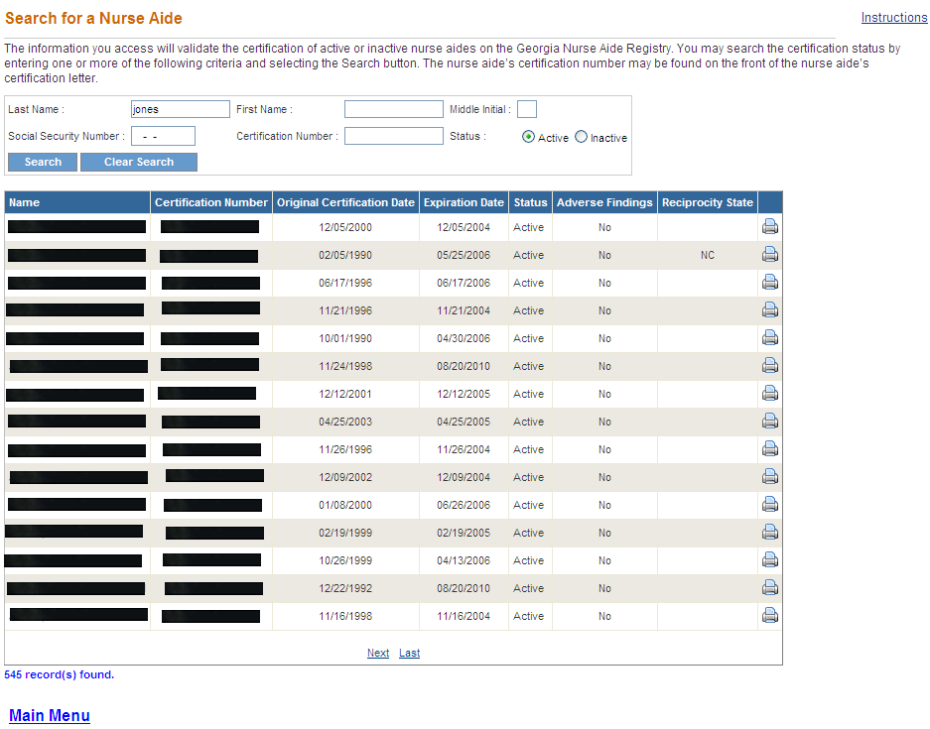

- This screen also displays the total number of results found. To view the next set of results, click on “Next” or to return to the previous set of results, click on “Previous.”
- To return to the Search for a Nurse Aide screen and search for another nurse aide, click the “Clear Search” button to clear all fields and enter new search criteria.
- To return to the Main Menu, click the “Main Menu” link.

