Search for a Testing Site

The Search for Testing Sites function allows the user to search for an approved nurse aide testing site. The Testing Site Search function consists of three windows: Search for Testing Sites, Search for Testing Sites - Initial Results, and Search for Testing Sites - Detailed Results.
How to Search for Testing Sites Window
The Testing Site Search window allows for the entry of geographic search criteria. The user can search for all testing sites near a particular location and within a designated mile radius. In order to perform a geographic search, users must enter a zip code, city or state.

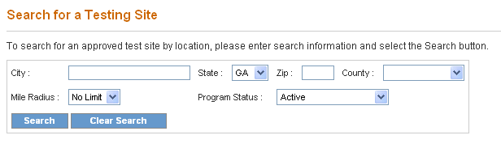
- In order to perform a geographic search for a testing site, a zip code, city or state can be entered. Enter the five-digit zip code for the search location in the Zip Code field. The other four digits of the zip code may also be entered. If the zip code is not known, enter a city in the City field, and/or select a state from the State drop down list.
- Other geographic search criteria may be entered to limit the search. To search by county, select an option from the County drop down list.
- The default setting for the Miles Radius field is No Limit. To search for a testing site within a different miles radius, select the preferred miles radius by selecting an option from the Miles Radius drop down list.
- The default Program Status is active. To search by a different status, select an option from the Program Status drop down list.
- Once all search criteria are entered, click the Search button at the bottom of the screen. The information entered is validated by the system. If an error message appears, make corrections and click Search again.
- If there are no matches to the search criteria, a message stating “0 record(s) found” will be displayed at the bottom of the page. Search again by entering new search criteria and then click the Search button at the bottom of the screen.
- If the search is successful, a Search for a Testing – Initial Results screen presents that lists the search criteria entered and displays all the Testing Sites matching any of the search criteria.
- The screen also displays the total number of results found. To view the next set of results, click on “Next.” To return to the previous set of results, click on “Previous.”
- To return to the Search for a Testing site screen and search for another Testing Site, click the “Clear Search” button and enter new search criteria.
OR
- To view detailed information for a testing site, click on the name of a testing site in the Name column. The Search for a Testing Site – Detailed Results screen is displayed.

