Search for/Submit a Complaint

This function allows users to search for a complaint filed about a Nurse Aide Training Program or submit a complaint about a Nurse Aide Training Program. Users can search for complaints that have been filed against a specific training program or by date filed, complaint type. Users can also add a complaint but clicking on the add complaint button on the search screen.

SEARCH FOR A COMPLAINT
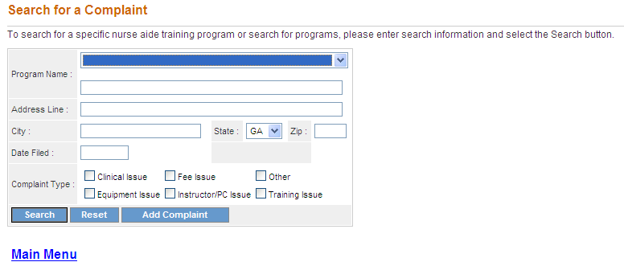
- On the Search screen, enter one or more complaint search criteria. The more specific the search criteria, the faster the search. To search for a specific complaint, select the program name from the Program Name drop down list.
- To limit the search to a particular type of complaint, select a type from one of the radio buttons (Clinical Issue, Equipment Issue, Fee Issue, Instructor/PC Issue, Other, Training Issue).
- Users may also limit their search to complaints filed on a particular date by entering a date in the Date Filed field. Dates are entered as (mm/dd/yyyy).
- Once all search criteria are entered, click the “Search” button at the bottom of the screen. The information entered is validated by the system. If an error message appears, make corrections and click the “Search” button again.
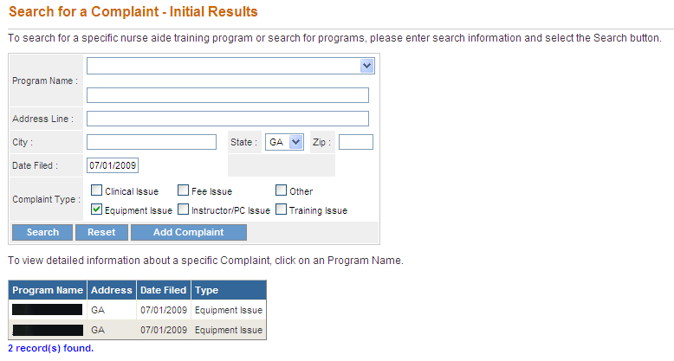

- If there are no matches to the search criteria, a “0 record(s) found” message is displayed. Users may search again by entering new search criteria and clicking on the “Search” button at the bottom of the screen.
- If the search is successful, the Search for a Complaint- Initial Results screen presents and displays the complaints matching any of the search criteria. For each result, this screen provides program name, address, date filed and complaint type.
- The screen also displays the total number of results found. To view the next set of results, click on “Next.” To return to the previous set of results, click on “Previous.”
- To view detailed information for a complaint, click the name of the program in the Program Name column. The View Complaint Details screen is displayed. This provides the following detailed information for the selected Complaint.
  - Program State Approved (yes/no)
  - Program Name
  - Program Address
  - Complaint Type
  - Explanation
  - Date Filed

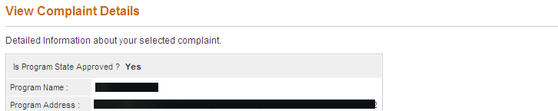
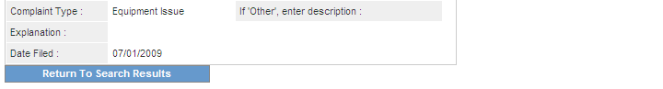

- To return to the previous search results, click the “Return to Search Results” button. To return to the Main Menu, click the “Main Menu” link.

SUBMIT A COMPLAINT

- On the Search screen, click on the “Add Complaint” button.

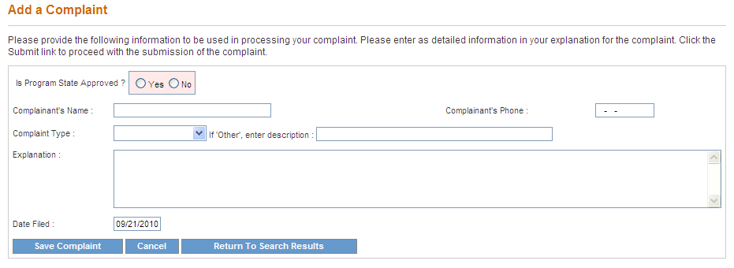
- Indicate whether the program is State Approved by selecting the Yes or No radio button.
- Enter the name of the person who is submitting the complaint in the Complainant’s Name field.
- Enter the Complainant’s phone number in the Complainant’s Phone field. Phone numbers are entered as (nnn-nnn-nnnn).
- Select the type of complaint using the Complaint Type drop list.
- Enter an explanation of the complaint.
- To submit the complaint, click the “Save/Submit Complaint” button.
- A message will be displayed confirming that the complaint has been submitted and that the complainant will be contacted by a representative within a number of days to discuss the issue.

